**ARKK Portfolio Concentration Analysis: Key Findings (Jan–Aug 2025)**

ARKK maintains ~37 holdings, but effective diversification is lower. The weight-based Herfindahl-Hirschman Index (HHI) averaged **0.051**, with values ranging between **0.047–0.057**, equivalent to ~18–21 effective positions. This remains well below thresholds for broad diversification.

**Concentration trends are stable.** From January through August, HHI remained consistently within a narrow band, suggesting that while the identity of leading contributors shifted over time, the overall structure of concentration did not change materially.

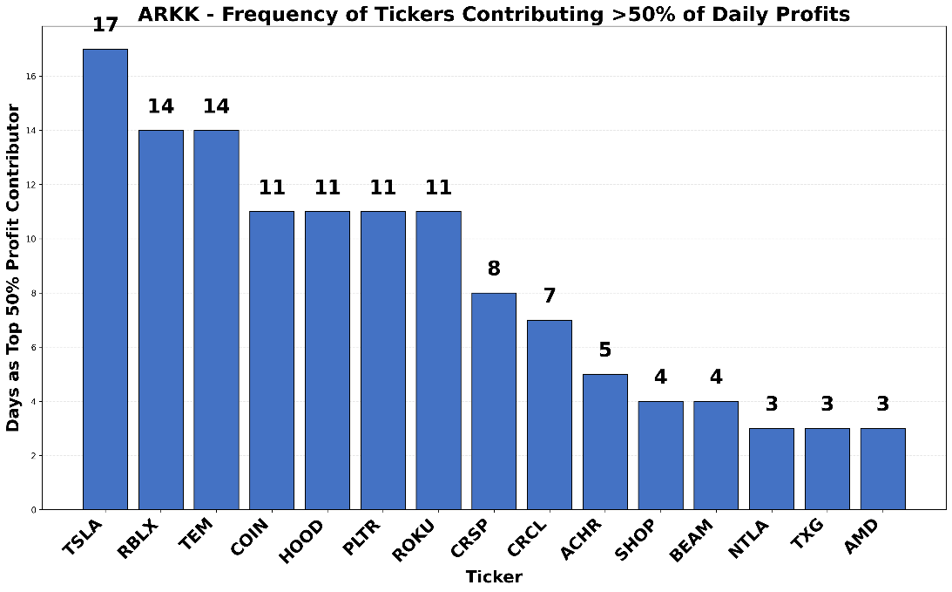

**Top contributors dominate outcomes.** Several stocks repeatedly drove daily performance. **TSLA (55 days), TEM (42), COIN (41), HOOD (39), ROKU (37), and RBLX (37)** were the most frequent sources of >50% of daily profits. This confirms that portfolio results are consistently linked to a small group of names.

**Profit contributions are concentrated.** Five stocks — **RBLX (16%), HOOD (16%), PLTR (14%), CRCL (14%), and COIN (7%)** — accounted for two-thirds of cumulative gains. The remaining ~30 holdings collectively contributed one-third.

**Losses are more narrowly distributed.** The largest detractors were **TSLA (25%), TWST (11%), GTLB (10%), BEAM (7%)**, and a handful of smaller positions. Together, these accounted for over 60% of cumulative losses. This indicates that negative performance is often concentrated in fewer names than positive performance.

**ARKW Portfolio Concentration Analysis: Key Findings (Jan–Aug 2025)**

ARKW holds around 30–35 names, but effective diversification is substantially lower. The Herfindahl-Hirschman Index (HHI) declined from **~0.056 in January** to **~0.040 by August**, corresponding to a shift from ~18 effective positions to ~25. While concentration eased slightly over time, the portfolio remains far from broadly diversified.  
**Concentration patterns persisted despite HHI decline.** While HHI values trended lower through the year, signaling broader distribution of weights, the actual return profile continued to be shaped by recurring leaders and a handful of consistent detractors.

**A small set of contributors dominates results.** Daily profit attribution shows that **ARKB (18 days), HOOD (16), TSLA (13), COIN (12), PLTR (12), and ROKU (11)** were the most frequent sources of more than 50% of daily profits. This indicates that portfolio performance repeatedly hinged on a narrow group of stocks.

**Profit contributions are uneven.** Cumulative gains were led by **ARKB (24%), HOOD (14%), RBLX (9%), CRCL (9%), and PLTR (8%)**, together accounting for nearly two-thirds of positive P&L. The remaining 25+ holdings collectively made up only 36%.

**Losses are concentrated in a few large detractors.** The largest contributors to cumulative losses were **TSLA (28%), TTD (15%), and XYZ (14%)**, alongside GTLB (11%) and BEAM (7%). Together, these five names represented over 70% of total losses, showing that downside risk was heavily concentrated.

**ARKQ Portfolio Concentration Analysis: Key Findings (Jan–Aug 2025)**

ARKQ maintains ~30 holdings, but effective diversification is lower. The Herfindahl-Hirschman Index (HHI) averaged **~0.052** during the period, equivalent to about **19–20 effective positions**. HHI trended downward in Q1, stabilizing around 0.048–0.051 through mid-year, indicating moderately high concentration.

**Concentration dynamics remained steady.** While the HHI declined early in the year, the composition of profit and loss contributors showed persistent concentration. Both upside and downside were explained by fewer than 10 names throughout the period.

**Daily attribution shows recurring leaders.** **KTOS (23 days) and TSLA (20 days)** most frequently contributed more than 50% of daily profits, followed by ACHR and PLTR (14 days each). Other contributors, such as RKLB and TER, appeared less often but still shaped daily outcomes.

**Profits were led by a few names.** Gains were dominated by **KTOS (32%) and PLTR (18%)**, with additional contributions from JOBY (7%), AVAV (6%), and OKLO (5%). The top five stocks together accounted for nearly 70% of cumulative profits.

**Losses were also concentrated.** The largest detractors were **a single bond proxy (29%), TSLA (26%), TER (14%), and IRDM (9%)**. These four names together explained ~80% of cumulative losses, showing that downside performance was similarly driven by a narrow group.

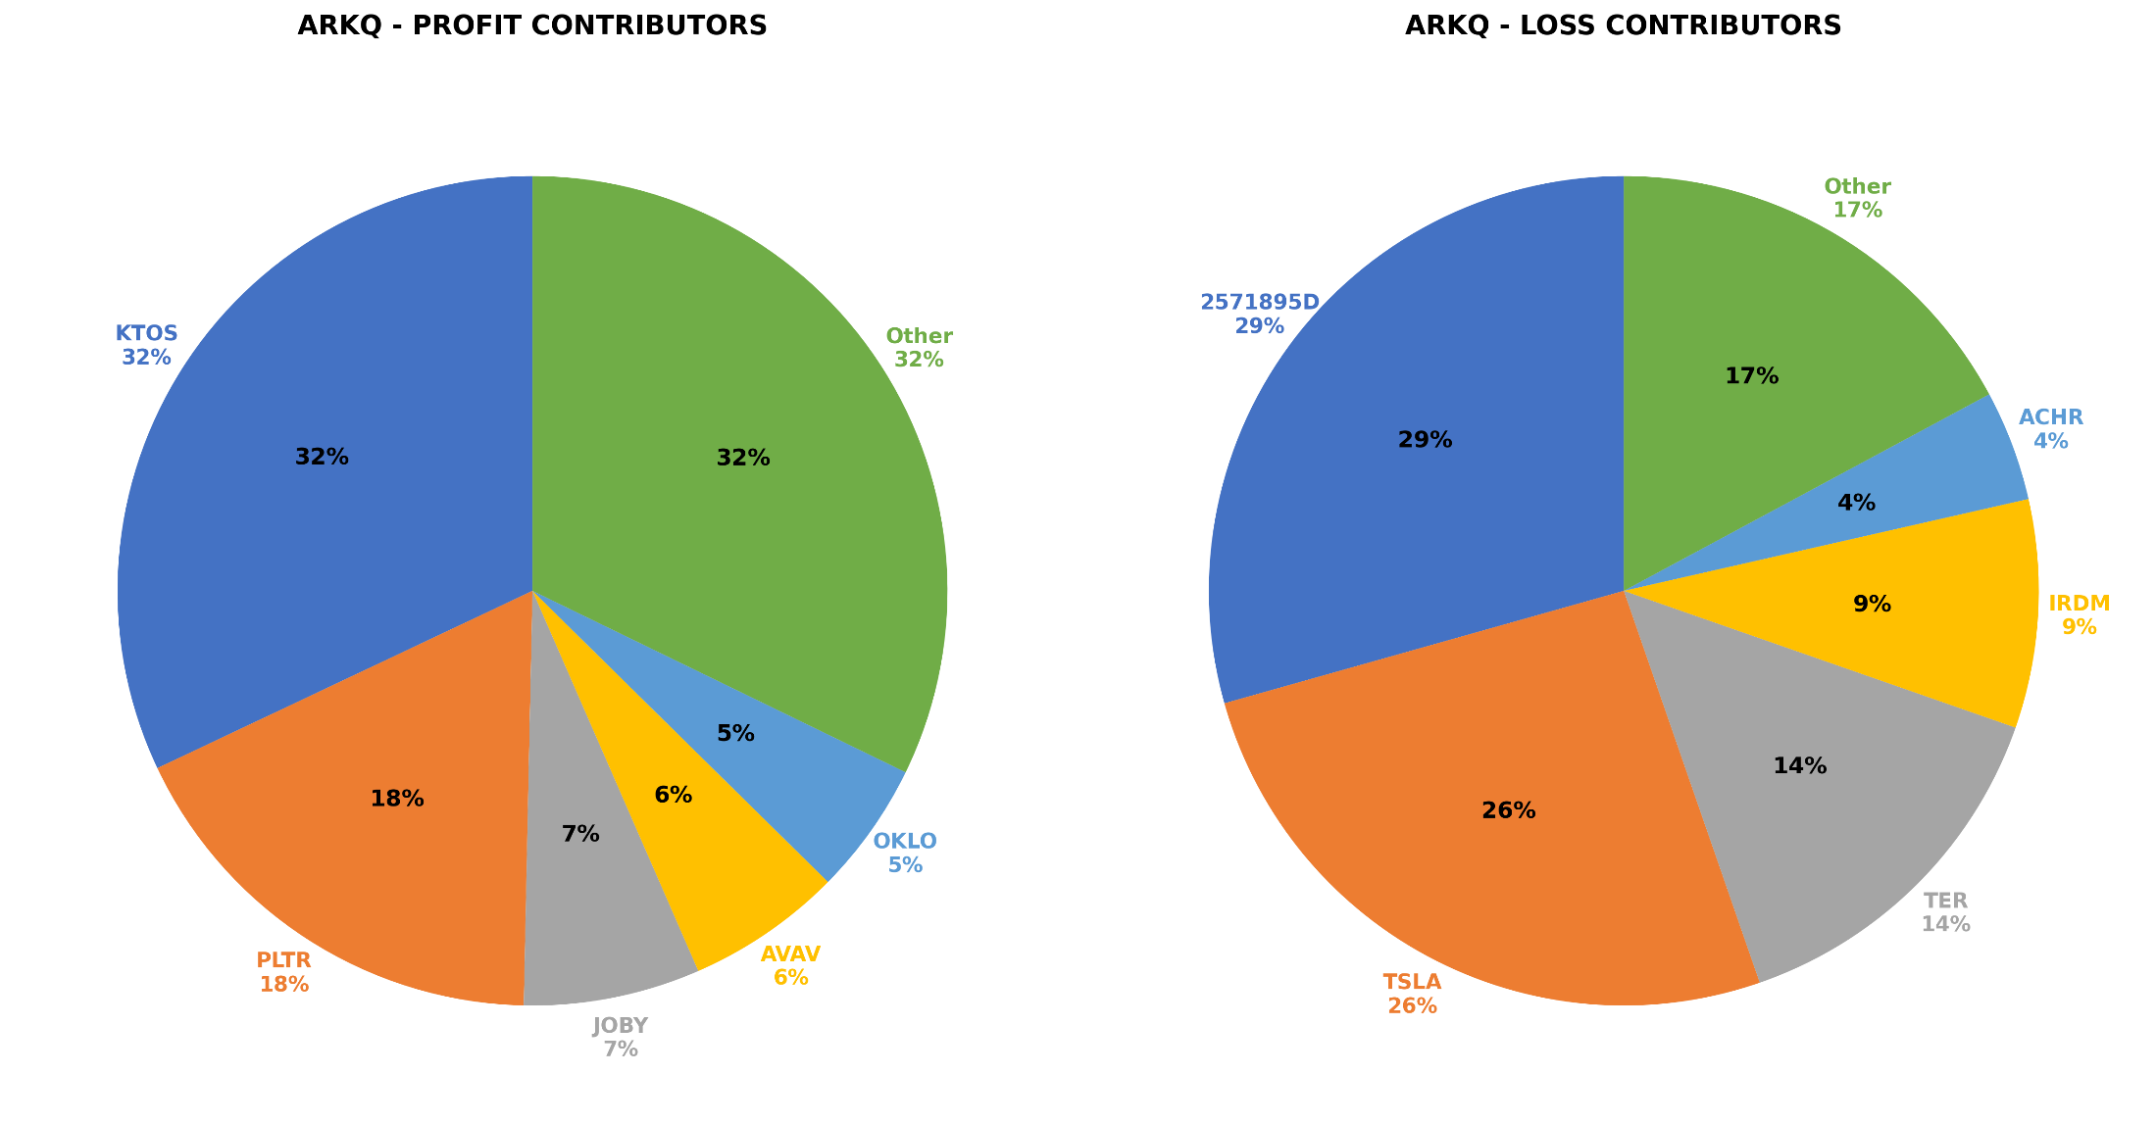

**ARKF Portfolio Concentration Analysis: Key Findings (Jan–Aug 2025)**

ARKF holds ~35 names, but effective diversification is narrower. The Herfindahl-Hirschman Index (HHI) fluctuated between **0.041–0.046**, corresponding to ~22–24 effective positions. While concentration is somewhat lower than other ARK funds, portfolio outcomes are still shaped by a limited set of holdings.

**Concentration dynamics were stable.** Despite modest fluctuations in HHI across the period, the distribution of gains and losses consistently reflected reliance on a narrow group of contributors.

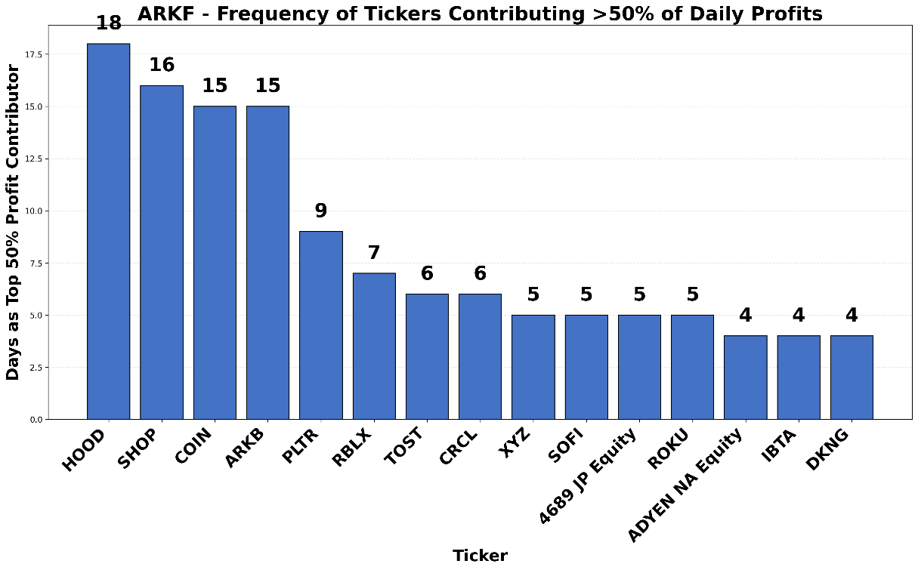

**Profits were led by a few core stocks.** The largest contributors were **HOOD (21%), CRCL (11%), PLTR (10%), RBLX (10%), and SHOP (9%)**. Together these five explained ~60% of cumulative gains, while the other 30+ names provided the remaining 40%.

**Losses were concentrated in a smaller group.** The largest detractors were **XYZ (21%), IBTA (19%), GLBE (16%), BILL (13%)**, and FTOXX (10%). Combined, these five positions accounted for ~80% of total losses.

**Daily leadership shows recurring patterns.** **HOOD (18 days), SHOP (16), COIN (15), and ARKB (15)** most frequently delivered more than 50% of daily profits. This confirms that daily outcomes were repeatedly driven by the same set of high-impact names.

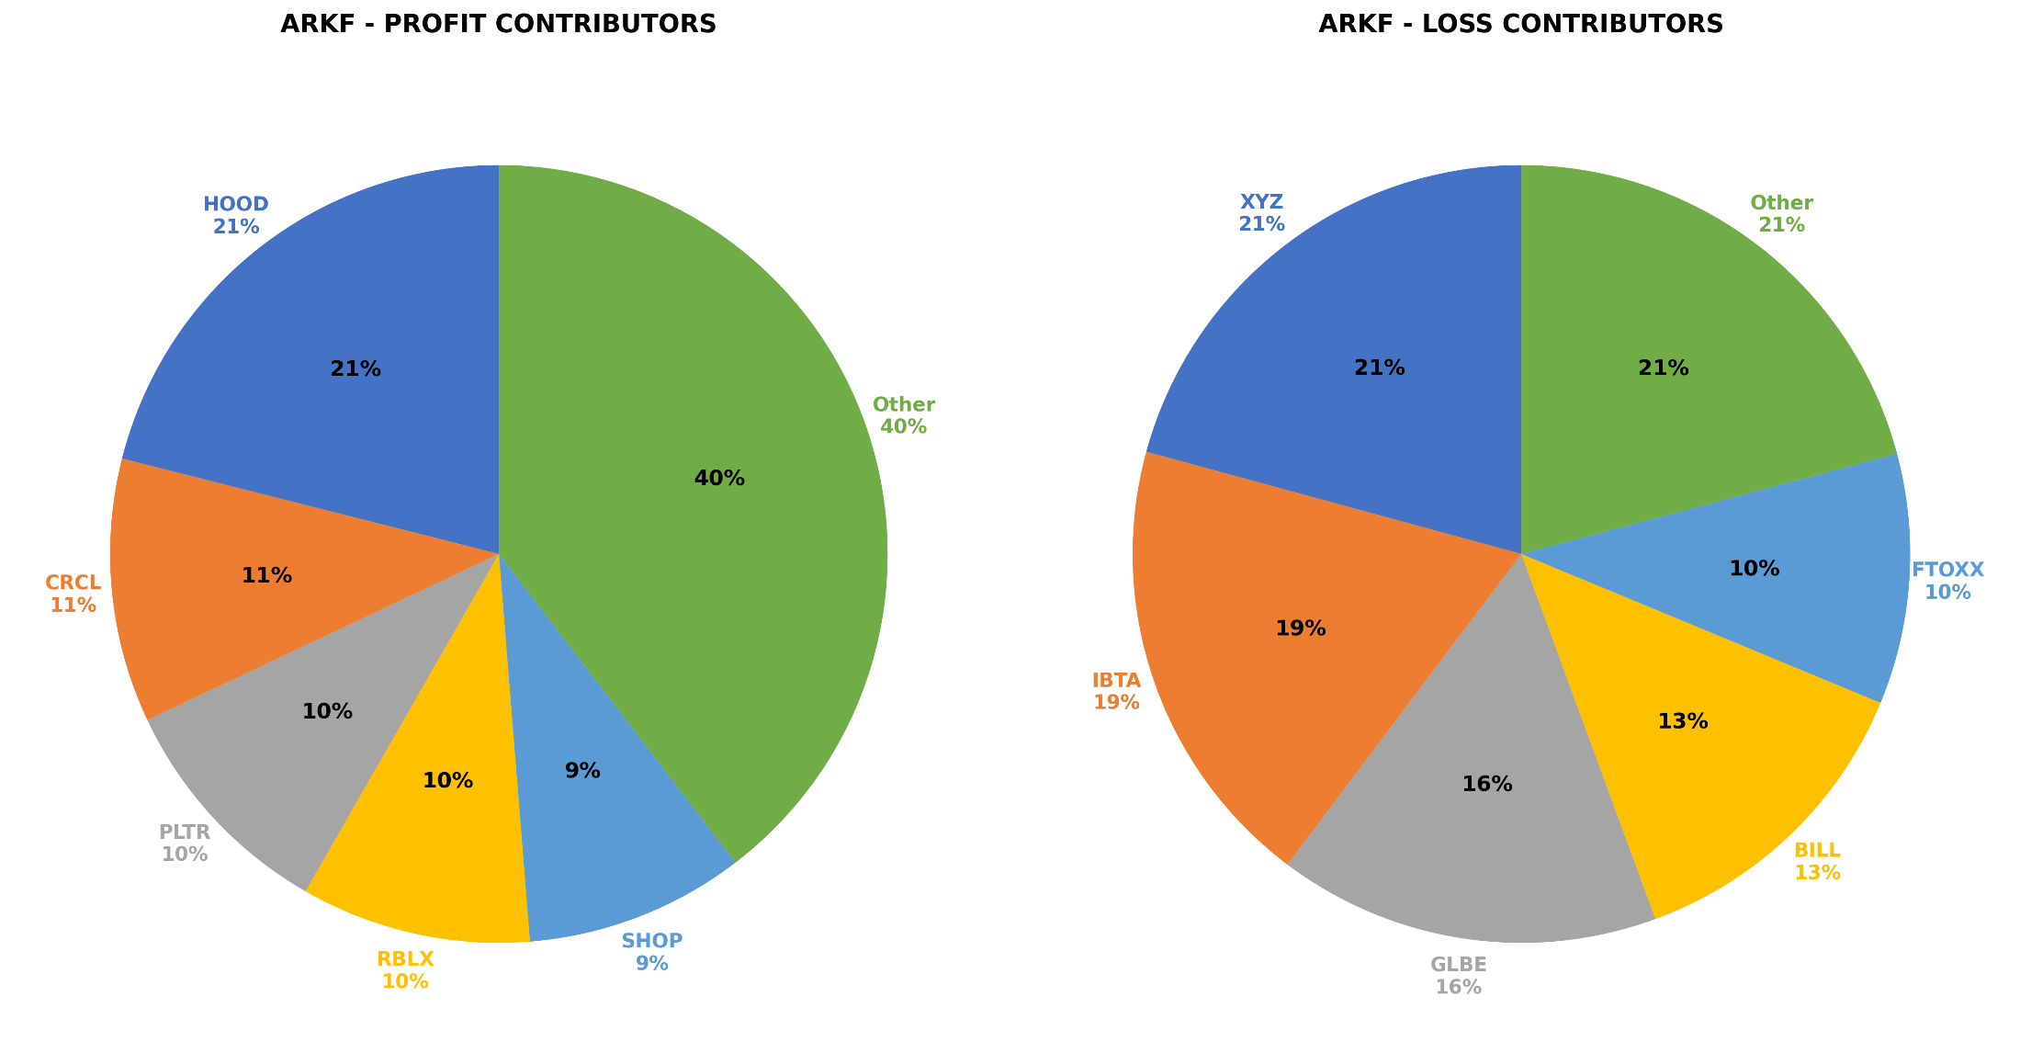

**ARKG Portfolio Concentration Analysis: Key Findings (Jan–Aug 2025)**

ARKG holds ~35–40 names, but effective diversification is narrower. The Herfindahl-Hirschman Index (HHI) fluctuated between **0.042–0.053**, corresponding to ~19–24 effective positions. Concentration increased during Q1–Q2, peaking above 0.052 in March–April, before moderating toward August.

**Concentration patterns were persistent.** While HHI declined slightly into late summer, both profits and losses continued to be explained by fewer than 10 stocks, underscoring the structural reliance on a concentrated group of holdings.

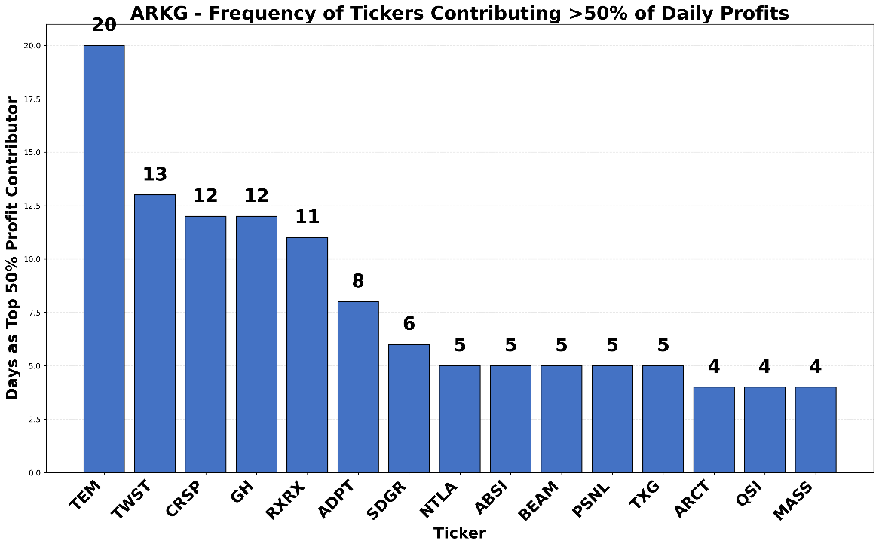

**Profits were concentrated in a few leaders.** The largest contributors were **CRSP (20%), ADPT (19%), TEM (18%), and GH (17%)**, together accounting for nearly three-quarters of cumulative gains. Smaller positive contributions came from ACCD (9%) and others.

**Losses were also driven by a limited set.** The main detractors were **TWST (20%), RXRX (10%), CDNA (10%), BEAM (8%), and QSI (8%)**, explaining over half of total losses. The remaining 30+ names collectively made up 44%.

**Daily attribution showed repeated dominance.** **TEM (20 days), TWST (13), CRSP (12), GH (12), and RXRX (11)** most frequently delivered more than 50% of daily profits. A small group of biotech names thus consistently shaped performance.

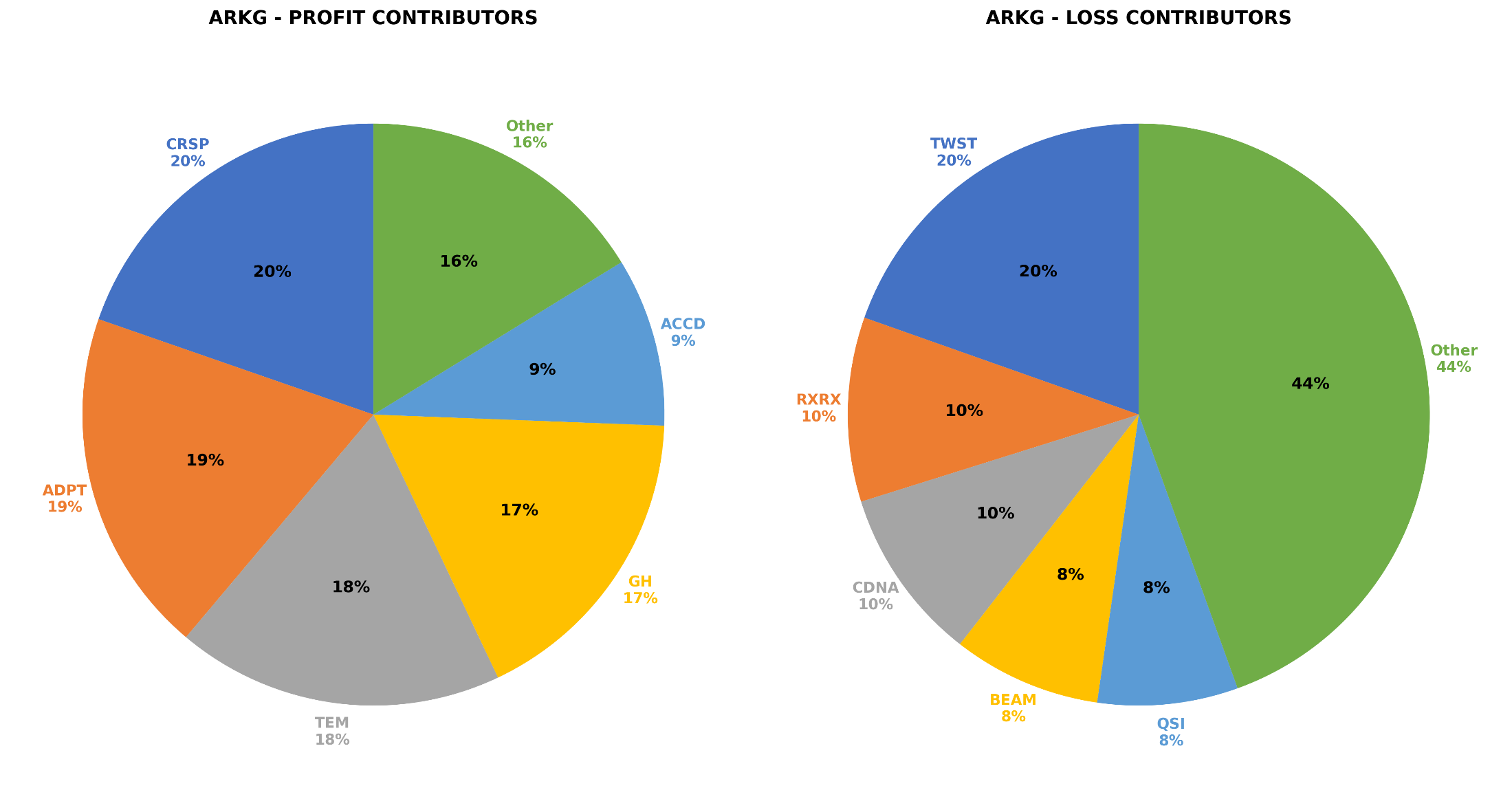

ARKX holds ~30 names, but effective diversification is lower. The Herfindahl-Hirschman Index (HHI) declined from **~0.060 in January** to **~0.045 in August**, corresponding to a shift from ~17 effective positions to ~22. This indicates concentration eased somewhat over time.

**Concentration moderated but remained meaningful.** Although HHI trended lower during the year, portfolio returns continued to be dominated by fewer than 10 stocks on both the profit and loss side.

**Profits were concentrated in a handful of names.** The largest contributors were **RBLX (16%), HOOD (16%), PLTR (14%), CRCL (14%), and COIN (7%)**, together accounting for nearly two-thirds of cumulative gains. The remaining 25+ stocks collectively provided one-third.

**Losses were also narrowly distributed.** The biggest detractors were **TSLA (25%), TWST (11%), TTD (10%), XYZ (8%), and BEAM (7%)**, explaining over 60% of total losses. Negative performance was concentrated in a smaller set of holdings than positive performance.

**Daily outcomes showed recurring leadership.** **TSLA (17 days), RBLX (14), and TEM (14)** most frequently contributed more than 50% of daily profits, followed by COIN, HOOD, PLTR, and ROKU (11 each). Daily attribution repeatedly relied on the same few leaders.

